Portfolio Optimization – Markowitz Mean-Variance Analysis

1. Overview
This analysis implements the classical Markowitz Mean–Variance Portfolio Optimization framework, which seeks to identify portfolios offering the best possible expected return for a given level of risk. Using daily historical data from a diversified universe of large-cap U.S. equities, the analysis estimates expected returns, covariances, and constructs the efficient frontier under realistic constraints.

2. Inputs and Outputs
The portfolio is composed of ten large-cap U.S. equities across major sectors. Data were sourced from Yahoo Finance between January 1, 2023, and November 1, 2025. The assets and their respective sectors are listed below:
Ticker | Company | Sector
AAPL | Apple Inc. | Technology
MSFT | Microsoft Corporation | Technology
GOOG | Alphabet Inc. | Communication Services
AMZN | Amazon.com Inc. | Consumer Discretionary
NVDA | NVIDIA Corporation | Semiconductors
JPM | JPMorgan Chase & Co. | Financials
V | Visa Inc. | Financials / Payments
XOM | Exxon Mobil Corporation | Energy
UNH | UnitedHealth Group Incorporated | Healthcare
META | Meta Platforms Inc. | Communication Services
The selection provides exposure to both growth-oriented and defensive industries, ensuring sector diversification and a realistic covariance structure.
The efficient frontier and tangent portfolio chart (Capital Market Line) are shown below:
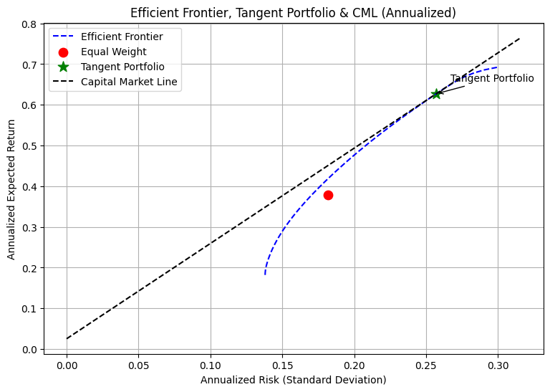

3. Methodology
The optimization minimizes portfolio variance subject to target return levels using convex optimization via CVXPY. Constraints include full investment (weights summing to 1), no short selling (weights ≥ 0), and a maximum allocation cap of 30% per asset. The efficient frontier is generated by iterating over a grid of target returns and solving for the minimum variance portfolio at each level.

4. Tangent Portfolio Optimization
The tangent (maximum Sharpe) portfolio is derived directly from the efficient frontier. For each portfolio on the frontier, the Sharpe ratio is computed as the excess return over risk-free rate divided by portfolio risk. The tangent portfolio corresponds to the maximum Sharpe ratio, representing the optimal risk-return tradeoff.

5. Results
Key portfolio metrics are summarized below:
Portfolio | Annual Return | Annual Risk | Sharpe Ratio
Equal Weight Portfolio | 37.93% | 18.16% | 1.950
Tangent Portfolio | 62.70% | 25.71% | 2.341

The tangent portfolio achieved a higher expected return and Sharpe ratio, demonstrating superior risk-adjusted performance relative to the equal-weight baseline. The tangent weights (subject to 30% per-asset cap) are as follows:
AAPL | 0.00
MSFT | 0.00
GOOG | 0.147
AMZN | 0.30
NVDA | 0.187
JPM | 0.00
V | 0.30
XOM | 0.00
UNH | 0.047
META | 0.018

6. Interpretation and Discussion
The efficient frontier illustrates the tradeoff between expected return and portfolio risk. Constrained optimization led to a frontier where diversification reduces overall variance while maintaining return potential. The tangent portfolio, representing the maximum Sharpe point, indicates an optimal mix of high-performing technology and consumer stocks, balanced with financial and healthcare exposure to reduce volatility.

7. Conclusion
This Markowitz analysis demonstrates how mean–variance optimization can be implemented using real financial data. By constraining weights and optimizing for the Sharpe ratio, the analysis identifies a practical portfolio configuration that aligns with real-world investment constraints while achieving an attractive risk-return balance.

